SIMATS ENGINEERING
Department of Computer Science and Engineering
ASSESSMENT TOOL 1 – INDUSTRY PROBLEM SOLVING TASK
Course Code: | CSA1220 | Course Title: | Computer Architecture
CO Assessed: | CO4 – Precision (BL4) | Assessment: | Industry Problem solving task
Weightage: | 30% | Total Marks: | 100
CO4 Statement: | Implement hierarchical memory systems by differentiating cache levels (L1, L2, L3), virtual memory with paging, and advanced memory technologies (DRAM, SRAM, NAND Flash, MRAM, RRAM) based on latency, bandwidth, and throughput characteristics.
Student Name: | P.Rishitha | Reg. No.: | 192472396
Section / Batch: | 2024 | Date: | 18/08/2026

Instructions to Students
• Identify the relevant concepts of cache hierarchy, SRAM, DRAM, MRAM, NAND Flash, RRAM, memory latency, bandwidth, and virtual memory paging.
• Analyze the memory-access requirements of smartphones, cloud servers, autonomous vehicles, edge AI devices, and gaming consoles, considering latency, bandwidth, capacity, and power consumption.
• Apply suitable memory-hierarchy techniques such as cache optimization, appropriate memory technology selection, data locality, paging optimization, and hierarchical memory organization.
• Compute performance measures such as memory access time, latency, bandwidth, throughput, speedup, hit/miss rates, and resource or power utilization where applicable.
• Interpret the results by evaluating performance improvements, memory bottlenecks, technology trade-offs, and the suitability of the proposed memory hierarchy for each application.

QUESTIONS
1. A high-frequency financial trading system must process large volumes of market data with extremely low response time. Analyze the roles of CPU caches, DRAM, and persistent storage in handling frequently accessed trading data. Considering latency, data locality, capacity, and bandwidth, propose a memory hierarchy that minimizes data-access delays and supports high transaction throughput.
2. A medical imaging workstation processes large CT and MRI datasets while simultaneously running image enhancement and visualization applications. Evaluate the interaction between cache memory, DRAM, and high-capacity storage during image processing. Propose an optimized memory hierarchy that balances access latency, memory capacity, bandwidth, and cost to improve overall processing performance.
3. A smart surveillance system receives continuous video streams from multiple high-resolution cameras and must detect objects in real time. Analyze the memory requirements for storing video frames, intermediate processing data, and frequently accessed detection parameters. Compare cache, DRAM, and non-volatile memory technologies and design a hierarchy that minimizes memory bottlenecks while maintaining high data throughput.
4. A scientific computing system performs large-scale simulations involving matrices and continuously accessed numerical datasets. Analyze how cache capacity, data locality, cache misses, DRAM bandwidth, and memory latency affect the execution of computational kernels. Recommend memory-hierarchy improvements that can reduce cache misses, increase effective memory bandwidth, and improve overall simulation performance.
5. A wearable health-monitoring device continuously collects sensor readings while operating under strict battery constraints. Analyze the trade-offs among SRAM, DRAM, and non-volatile memory in terms of latency, capacity, energy consumption, and data retention. Design a memory hierarchy that provides rapid access to frequently processed sensor data while minimizing power consumption and extending battery life.
Code of Conduct
I P.Rishitha (192472396) (Name / Reg No) certify that this submission is my original work and that I have adhered to the guidelines specified for this assessment. I understand that any violation of academic integrity rules will result in disciplinary action.
Signature of the Student: P.Rishitha
RUBRICS FOR CALCULATION
Criteria | Weightage(%) | Level 4 – Exemplary (5 Marks) | Level 3 –  Proficient (4  Marks) | Level 2 –  Developing  (2–3 Marks) | Level 1 – Beginning (0–1 Mark)
Understanding of Industry  Problem | 20% | Comprehensive  understanding of real-world problem and constraints | Good  understanding with minor gaps in requirements | Basic  understanding; some  requirements  unclear | Poor  understanding;  misinterprets  problem context
Application of Engineering  Concepts | 25% | Applies advanced and relevant  concepts effectively to solve the  problem | Applies  appropriate  concepts with  minor errors | Limited  application of  concepts | Incorrect or no  application of  concepts
Solution Design | 25% | Innovative,  practical, and  feasible solution  aligned with  industry standards | Logical and  feasible solution with minor gaps | Basic solution  with limited  feasibility | Unclear or  impractical  solution
Use of Tools | 15% | Effective use of  modern tools,  technologies, and real data | Appropriate use of tools with  correct  implementation | Limited or  inconsistent use of tools | Minimal or  incorrect use of  tools
Analysis | 10% | Thorough analysis with validated  results and  performance  evaluation | Good analysis  with reasonable validation | Basic analysis  with limited  validation | Poor or no  analysis
Professionalism | 5% | Highly professional, well-documented, and clearly  presented work | Good  documentation and  presentation | Basic  documentation with some gaps | Poor  documentation  and presentation

Marks Evaluation:
Q.  No | Understanding of Industry  Problem (20) |  | Application of  Engineering Concepts (25) |  | Solution  Design (25) | Use of Tools  (15) | Analysis (10) | Professiona lism(5) | Total  (out of 100)
1 | / 4 |  | / 4 |  | / 4 | / 4 | / 4 | / 4
2 | / 4 |  | / 4 |  | / 4 | / 4 | / 4 | / 4
3 | / 4 |  | / 4 |  | / 4 | / 4 | / 4 | / 4
4 | / 4 |  | / 4 |  | / 4 | / 4 | / 4 | / 4
5 | / 4 |  | / 4 |  | / 4 | / 4 | / 4 | / 4
 | / 25 |  | / 30 |  | / 20 | / 15 | / 10 |  | / 100

Course Coordinator Faculty Incharge

Q1. High-Frequency Financial Trading System

Introduction
A high-frequency trading (HFT) system processes a very large number of market-data transactions within extremely short time intervals. In such systems, even a few nanoseconds of additional memory-access latency can affect performance. Therefore, an efficient memory hierarchy is required to keep frequently accessed trading data as close to the CPU as possible.
The main memory components considered are L1, L2 and L3 cache, DRAM, and persistent storage.

Role of Different Memory Levels

L1 Cache
L1 is the smallest and fastest cache located closest to the CPU.
- Stores the most frequently accessed trading data and instructions.
- Has very low latency.
- Has limited capacity.
- Provides the fastest access to data.
- Suitable for current stock prices, order-book entries and frequently executed trading instructions.

L2 Cache
L2 is larger than L1 but slightly slower.
- Stores data that cannot fit in L1.
- Reduces the number of accesses to DRAM.
- Useful for maintaining a larger set of active market data.
- Provides a balance between capacity and latency.

L3 Cache
L3 is larger than L1 and L2 and is generally shared among CPU cores.
- Stores frequently reused market datasets.
- Reduces DRAM accesses.
- Useful when several trading processes or CPU cores need common data.
- Has higher latency than L1 and L2 but much lower latency than DRAM.

DRAM
DRAM acts as the main memory.
- Provides much greater capacity than CPU caches.
- Stores the active trading dataset.
- Holds larger market-data structures and order books.
- Has higher latency than cache.
- Provides high bandwidth for transferring large amounts of data.

Persistent Storage
Persistent storage such as NVMe SSD/NAND Flash is used for large and permanent datasets.
- Stores historical market data.
- Stores transaction logs and trading records.
- Provides very high capacity.
- Data remains available after power is removed.
- Has much higher latency than cache and DRAM.
Therefore, latency-sensitive trading data should not depend on storage during the critical trading path.

Proposed Memory Hierarchy
The proposed hierarchy is:
4. Data Placement :

Data | Recommended Location | Reason
Current stock price | L1/L2 | Extremely frequent access
Active order book | L2/L3 | Frequently updated
Recent market data | L3/DRAM | Larger working dataset
Complete active market dataset | DRAM | Large capacity
Historical market data | NVMe/NAND | Large persistent storage
Transaction logs | NVMe/NAND | Permanent retention

Importance of Data Locality
Data locality is extremely important in HFT systems.

Temporal locality
If a trading program accesses the same data repeatedly, that data should remain in the cache.

Spatial locality
Related data should be stored close together in memory.
For example, frequently accessed entries of an order book can be organized in contiguous memory locations. This allows cache lines to bring related data into the cache together.

Bandwidth
Bandwidth represents how much data can be transferred per unit of time.
DRAM and modern storage provide much higher capacity than cache, but the CPU should avoid unnecessary movement of data between levels because it increases memory traffic.

Cache Hit and Miss
A cache hit occurs when the required data is found in the cache.
A cache miss occurs when the data is not found and the next memory level must be accessed.
The cache hit rate is:
Hit Rate=Total Memory Accesses Cache Hits​×100
The miss rate is:
Miss Rate=100−Hit Rate
A high cache hit rate is desirable because it reduces average memory-access latency. Throughput
Transaction throughput is:
Throughput=Total Processing Time Number of Transactions​

Optimization Techniques
The following techniques can improve the proposed memory hierarchy:
- Increase cache hit rate by keeping frequently used data in cache.
- Improve data locality by arranging related trading data close together.
- Reduce unnecessary memory transfers between cache and DRAM.
- Use cache-friendly data structures for order books and market data.
- Keep latency-critical data in DRAM or cache, rather than accessing storage.
- Use high-bandwidth DRAM for large active datasets.
- Use NVMe/NAND storage for historical data and transaction logs.
- Use multiple CPU cores carefully while taking advantage of shared L3 cache.
- Use prefetching where predictable market-data access patterns exist.
- Avoid paging or swapping during latency-critical trading operations.

Implementation :
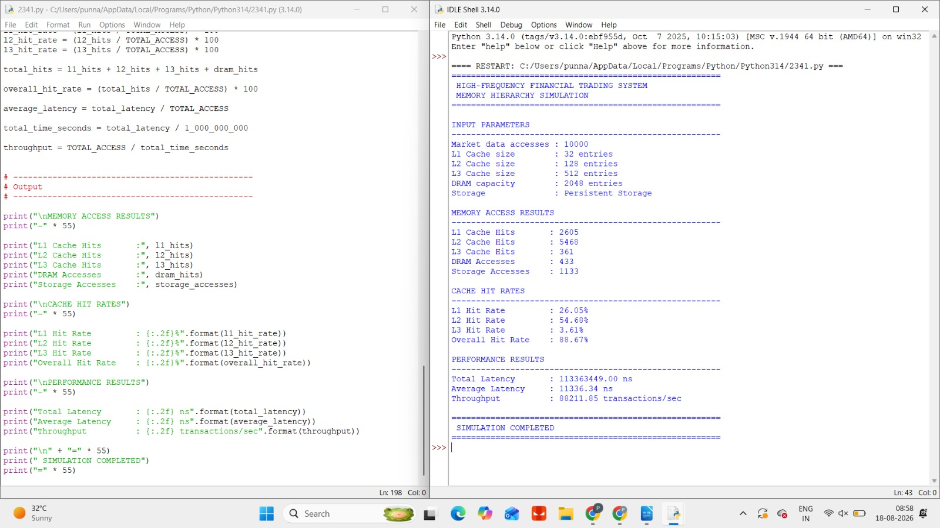

Q2. Medical Imaging Workstation – Answer
A medical imaging workstation handles large CT and MRI datasets while simultaneously performing image enhancement, reconstruction, analysis, and visualization. Therefore, the memory hierarchy must provide low latency for frequently accessed data, high bandwidth for image processing, large capacity for complete datasets, and reasonable cost.

Role of Cache, DRAM and Storage

Cache Memory
CPU cache is the fastest memory in the hierarchy.
- L1 cache: Stores frequently used image-processing instructions and small portions of image data.
- L2 cache: Holds a larger working set used by the processing algorithms.
- L3 cache: Provides a larger shared cache for multiple CPU cores.
- Reduces the number of accesses to DRAM.
- Exploits temporal and spatial locality.
For example, during image enhancement, the same neighboring pixels may be accessed repeatedly. Keeping these pixels in cache reduces memory-access latency.

DRAM
DRAM acts as the main working memory.
It stores:
- Active CT/MRI datasets
- Image slices
- Intermediate processing results
- 3D reconstruction data
- Visualization buffers
DRAM provides much greater capacity than cache, but its latency is higher.

High-Capacity Storage
SSD/NVMe storage is used for:
- Original CT/MRI scans
- Patient imaging datasets
- Historical images
- Processed images
- Backup and archival data
Storage provides very high capacity but is much slower than cache and DRAM. Therefore, frequently processed data should be loaded into DRAM before intensive processing.

Data Locality
Data locality is particularly important for medical image processing.

Spatial Locality
Pixels located near each other are often processed together.

Temporal Locality
If the same image data is repeatedly used during enhancement, keeping it in cache avoids repeatedly fetching it from DRAM.

Optimized Design
For better performance, the workstation should use:

1. Cache blocking
Divide large images into smaller blocks.

2. Large-capacity DRAM
Sufficient DRAM should be provided so that the active CT/MRI dataset and intermediate results remain in memory.
This avoids frequent storage accesses.

3. High-bandwidth memory subsystem
Image processing involves transferring large quantities of pixel/voxel data. Therefore, high DRAM bandwidth is important.

4. Fast NVMe storage
Large CT/MRI datasets should be stored on high-speed NVMe SSDs so that datasets can be loaded quickly when required.

5. Multi-core processing
Different image blocks can be processed simultaneously by different CPU cores while sharing L3 cache.

Memory Bottlenecks
Potential bottlenecks include:
- Insufficient DRAM capacity
- Low DRAM bandwidth
- Frequent cache misses
- Poor data locality
- Repeated storage access
- Large intermediate image-processing datasets
- Multiple applications competing for memory bandwidth
These can be reduced through cache blocking, prefetching, sufficient DRAM, high-bandwidth memory, and fast NVMe storage.

Result Analysis
The proposed hierarchy keeps frequently accessed pixels, image blocks, and processing instructions in cache, while the complete active CT/MRI dataset is maintained in DRAM. Large original and historical datasets remain on NVMe/SSD storage.
Cache blocking improves data locality and reduces unnecessary DRAM accesses. Sufficient DRAM capacity prevents repeated loading of datasets from storage, while high memory bandwidth supports the large volume of data required by image enhancement and visualization.
Thus, the hierarchy provides a good balance between latency, capacity, bandwidth, and cost.

Conclusion
An optimized medical imaging workstation should use a multi-level cache hierarchy, high-capacity/high-bandwidth DRAM, and fast NVMe storage. Cache handles latency-sensitive processing, DRAM handles active CT/MRI datasets, and persistent storage handles large permanent datasets. Using data locality, cache blocking, prefetching, and sufficient DRAM capacity reduces memory bottlenecks and improves overall image-processing performance.

IMPLEMENTATION :
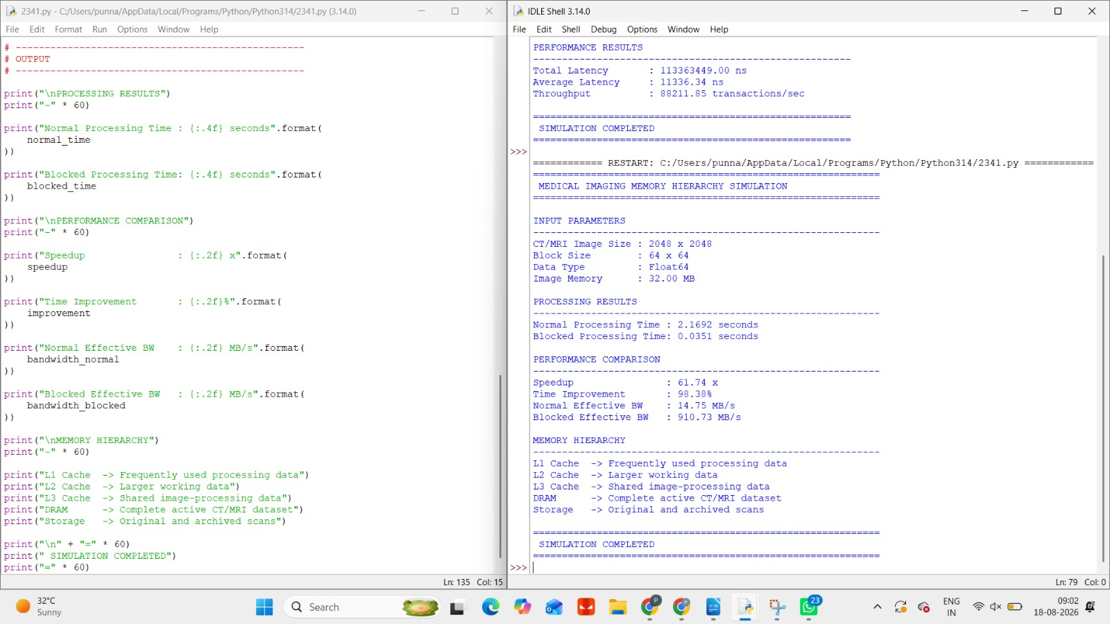

Q3. Smart Surveillance System – Answer
A smart surveillance system continuously receives video streams from multiple high-resolution cameras and must detect objects such as people, vehicles, bicycles, and other objects in real time. Since video data arrives continuously and at high speed, the memory hierarchy must provide high bandwidth, low latency, sufficient capacity, and efficient data movement.

1. Memory Requirements
A surveillance system mainly handles three types of data:

A. Video Frames

B. Intermediate Processing Data
During object detection, the system generates:
- Resized frames
- Image-processing buffers
- Feature maps
- Bounding boxes
- Object coordinates
- Detection results
This data must be accessed quickly because object detection must happen in real time.

C. Detection Parameters
Detection models frequently access:
- Model weights
- Threshold values
- Object-class information

Role of Cache Memory
Cache is the fastest memory available to the CPU.

L1 Cache
Stores the most frequently accessed:
- Detection instructions
- Small processing data
- Frequently used parameters
It provides extremely low latency but has very small capacity.

L2 Cache
Stores a larger working set of detection data and processing instructions.

L3 Cache
Provides a larger shared cache and can be useful when multiple CPU cores are processing different camera streams.
The main objective is to maintain high cache hit rates for frequently accessed detection parameters.

Role of DRAM
DRAM acts as the main working memory of the surveillance system.
It can store:
- Current video frames
- Multiple camera buffers
- Intermediate image-processing results
- Object-detection data
- Tracking information
Unlike cache, DRAM provides much larger capacity.
However, DRAM has higher latency than cache, so efficient buffering and data locality are important.

Role of Non-Volatile Memory
Non-volatile memory such as NAND Flash/SSD is mainly used for permanent storage.
It can store:
- Recorded video
- Historical surveillance footage
- Detection logs
- Event records
- System configuration
- Important snapshots
It has very large capacity but much higher access latency than cache and DRAM.
Therefore, real-time object detection should not depend on persistent storage for every frame.
Data Placement :

Data | Memory | Reason
Detection parameters | L1/L2 Cache | Very frequent access
Frequently used model data | L2/L3 Cache | Low latency
Current video frames | DRAM | Large active data
Intermediate processing data | DRAM/Cache | Fast processing
Object tracking information | DRAM/Cache | Continuous access
Recorded video | NVMe/NAND | Large capacity
Historical footage | NVMe/NAND | Persistent storage

Memory Bottlenecks
The major memory bottlenecks are:

1. High video-data rate
Multiple high-resolution cameras generate large amounts of data continuously.

2. DRAM bandwidth
Several camera streams may access DRAM simultaneously. Insufficient bandwidth can cause delays.

3. Cache misses
If detection parameters are not present in cache, the processor has to access lower memory levels.

4. Frame buffering
Insufficient DRAM can result in frame-buffer overflow and dropped frames.

5. Storage bandwidth
Recording multiple high-resolution streams requires sufficient storage write bandwidth.

Throughput
The system must process frames quickly enough to keep up with incoming cameras.
Frame-processing throughput can be calculated as:
Throughput=Processing TimeFrames Processed​
For example, if a system processes 1,000 frames in 10 seconds:
Throughput=101000​ =100 frames/sec
A higher throughput means the system can handle more camera streams in real time.

Memory Bandwidth
Memory bandwidth is particularly important because video processing continuously transfers large amounts of data.
A simplified effective bandwidth is:
Bandwidth=TimeAmount of Data Transferred​
Higher DRAM bandwidth allows more video frames and intermediate data to be processed simultaneously.

Optimization Techniques
The following techniques can improve surveillance performance:

1. Frame buffering
Maintain multiple frame buffers in DRAM so incoming camera frames can be processed without interruption.

2. Cache-friendly processing
Process image blocks to improve spatial locality.

3. Prefetching
Predict and load upcoming video data before the CPU needs it.

4. Multi-core/GPU processing
Different camera streams can be processed in parallel.

5. Reduce unnecessary data movement

Keep intermediate data close to the processing unit.

6. Efficient storage
Use high-speed NVMe storage for continuous video recording.
Result Analysis
The proposed hierarchy minimizes memory bottlenecks by assigning each type of data to an appropriate memory level. Frequently accessed detection parameters are kept in cache to reduce latency. Current frames and intermediate processing data are maintained in DRAM because they require high capacity and bandwidth. Recorded video is transferred to non-volatile storage for long-term retention.
Efficient buffering, cache-friendly processing, high DRAM bandwidth, and reduced data movement help prevent frame drops and maintain real-time object detection.

Conclusion
A smart surveillance system requires a memory hierarchy capable of handling continuous high-bandwidth video streams. The proposed L1 → L2 → L3 → DRAM → NVMe/NAND hierarchy provides a suitable balance between latency, capacity, bandwidth, and persistence.
By keeping frequently accessed detection parameters in cache, video frames in high-capacity DRAM, and recorded footage in non-volatile storage, the system can minimize memory bottlenecks and maintain high-throughput real-time object detection.
IMPLEMENTATION :
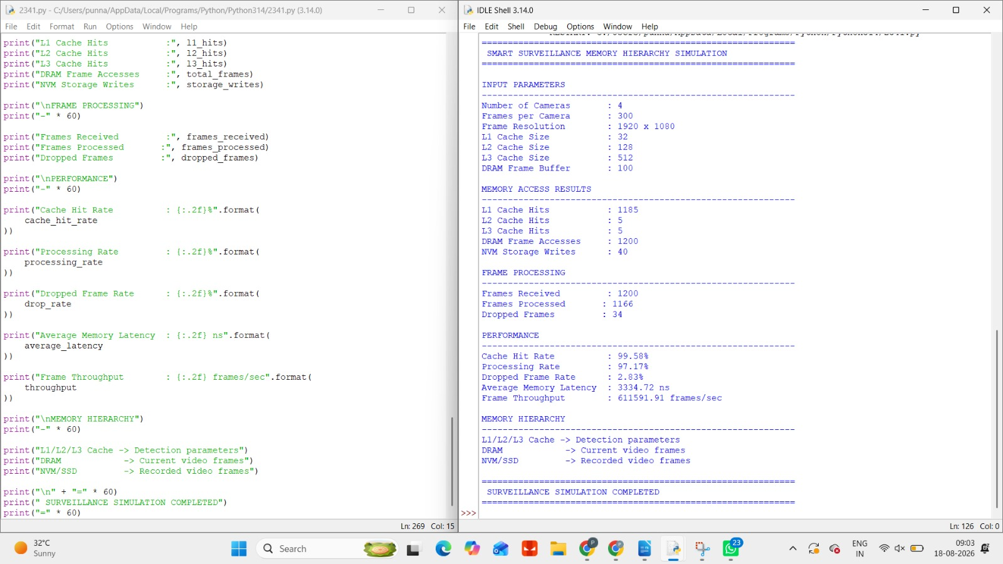

Q4. Scientific Computing System – Answer
A scientific computing system performs large-scale simulations involving matrices, numerical datasets, and computational kernels. These applications perform a large number of memory accesses, so the performance depends strongly on cache capacity, data locality, cache misses, DRAM bandwidth, and memory latency.

1. Role of Cache Memory
Cache memory stores frequently accessed data close to the CPU.
The cache hierarchy consists of:
- L1 Cache – smallest and fastest
- L2 Cache – larger but slower than L1
- L3 Cache – larger shared cache, slower than L1/L2
For scientific applications, matrices and numerical arrays are repeatedly accessed. Keeping frequently used portions of these arrays in cache reduces the need to access DRAM.

Effect of Cache Capacity
Cache capacity determines how much frequently accessed data can remain close to the processor.

Data Locality
Data locality is one of the most important factors in scientific computing.

Spatial Locality
Spatial locality means accessing data stored close together.

Temporal Locality
Temporal locality means reusing data that was recently accessed.

Cache Misses
A cache miss occurs when the required data is not present in the cache.
Types include:

Compulsory Miss
Occurs when data is accessed for the first time.

Capacity Miss
Occurs when the working dataset is larger than the cache.

Conflict Miss
Occurs when multiple data blocks compete for the same cache location.
A high cache-miss rate increases DRAM traffic and slows down computational kernels.

Cache Blocking / Tiling
One of the most effective optimization techniques is blocking, also called tiling.
Instead of processing an entire large matrix at once, divide it into smaller blocks.

Advantages
- Improves spatial locality
- Improves temporal locality
- Reduces cache misses
- Reduces DRAM traffic
- Improves effective bandwidth
- Improves computational performance

Optimization Techniques
The following techniques are recommended:

1. Cache blocking
Divide matrices into cache-friendly blocks.

2. Improve data locality
Access contiguous memory locations whenever possible.

Result Analysis
The performance of large-scale scientific simulations is strongly affected by the memory hierarchy. When frequently reused matrix elements remain in cache, the processor can access them quickly. Poor locality increases cache misses and forces more accesses to DRAM, increasing memory latency.
Cache blocking/tiling improves both spatial and temporal locality by keeping a smaller working set in cache. Increasing DRAM bandwidth further helps when the workload is memory-bound. Prefetching and parallel processing can also hide memory latency and increase throughput.

Conclusion
An efficient memory hierarchy for scientific computing should use L1, L2 and L3 caches for frequently reused numerical data, high-bandwidth DRAM for active matrices, and high-capacity storage for large simulation datasets.
The most important improvements are cache blocking, improved data locality, prefetching, reduced cache misses, and increased effective DRAM bandwidth. These techniques reduce memory-access delays and improve the overall performance of large-scale scientific simulations.
IMPLEMENTATION :
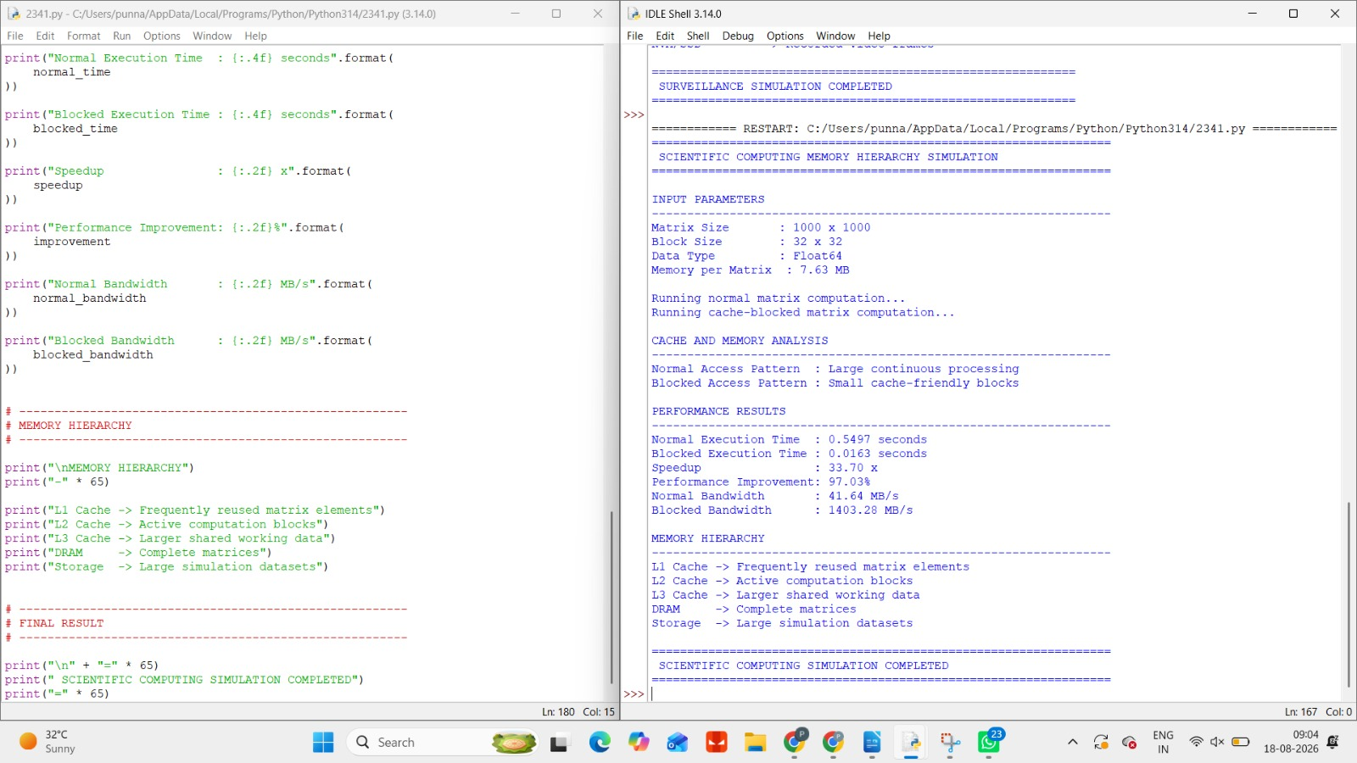

5.Wearable Health-Monitoring Device
A wearable health-monitoring device continuously collects data from sensors such as heart rate, SpO₂, body temperature, ECG, and motion sensors. Since the device is battery-powered, its memory hierarchy must provide fast access to frequently processed data while minimizing energy consumption.
The main memory technologies considered are SRAM, DRAM, and non-volatile memory (NVM).

Memory Requirements
The wearable system handles three major types of data:

A. Frequently Processed Sensor Data
Examples:
- Current heart rate
- Current SpO₂ value
- Temperature
- Motion data
- Recent ECG samples
This data needs very fast access, so SRAM/cache is suitable.

B. Temporary/Active Data
The device may maintain:
- Recent sensor history
- Signal-processing buffers
- Filtered sensor readings
- Intermediate calculations
This requires more capacity than SRAM, so DRAM can be used.

C. Permanent Data
Examples:
- Long-term health records
- Sensor logs
- Device configuration
- Important event records
This data should be stored in non-volatile memory, such as NAND Flash or other NVM technologies, because it must remain available even when power is removed.

SRAM
SRAM is very fast and does not require refresh cycles.

Advantages
- Very low latency
- High-speed access
- Good for frequently accessed data
- No refresh operation required

Disadvantages
- Small capacity
- Expensive per bit
- Higher area requirement

DRAM
DRAM provides much greater capacity than SRAM.

Advantages
- Larger capacity
- Lower cost per bit than SRAM
- Suitable for temporary working data

Disadvantages
- Higher latency than SRAM
- Requires periodic refresh
- Consumes more energy than SRAM for some low-power workloads

Non-Volatile Memory
NVM retains data even when the device is powered off.
Examples include:
- NAND Flash
- NOR Flash
- MRAM
- RRAM

Advantages
- Data retention without power
- Large storage capacity depending on technology
- Suitable for long-term records

Disadvantages
- Generally slower than SRAM/DRAM for active processing
- Flash has limited write endurance
- Write operations can consume significant energy

Result Analysis
The proposed hierarchy places frequently processed sensor data in SRAM/cache, providing very low latency. DRAM acts as a larger temporary buffer for sensor readings and intermediate processing results. NVM provides persistent storage for historical health data and important records.
By maximizing SRAM reuse, reducing unnecessary DRAM accesses, and batching NVM writes, the system can reduce memory-related energy consumption. This is particularly important in a wearable device because lower memory power consumption contributes to longer battery life.

Conclusion
A wearable health-monitoring device requires a memory hierarchy that balances speed, capacity, energy consumption, and data retention.
The proposed:
SRAM/Cache → DRAM → NVM
hierarchy provides fast access to frequently processed sensor readings, sufficient capacity for active data, and permanent storage for historical information.
The use of data locality, buffering, batch NVM writes, and low-power memory operation reduces unnecessary memory activity and helps extend the battery life of the wearable device while maintaining real-time health monitoring performance.
IMPLEMNTATION :

